DSA Lab09

23K2001

M.Muzammil Siddiqui

BCS-3J

Q1:

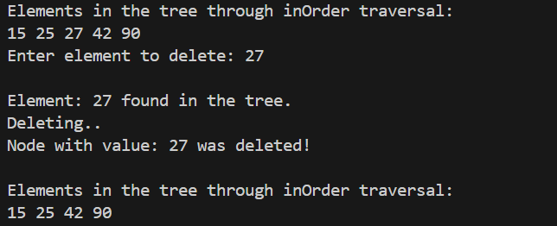

Q2:

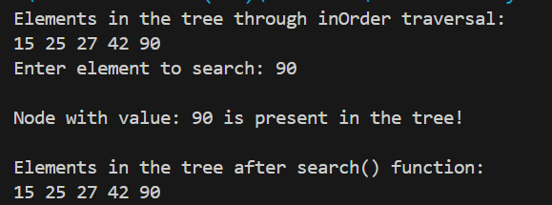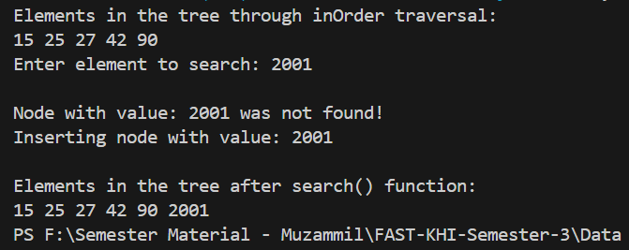

Q3:

Q4:

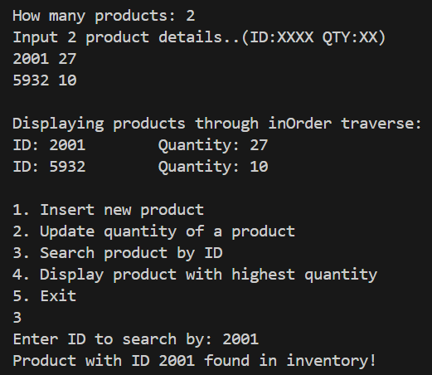

Q5:

Q6:

